State Machines and the LCD Display
Module | ET4047
Date | 28/10/2026
Lab No. | Lab 6
Author | Luke Griffin

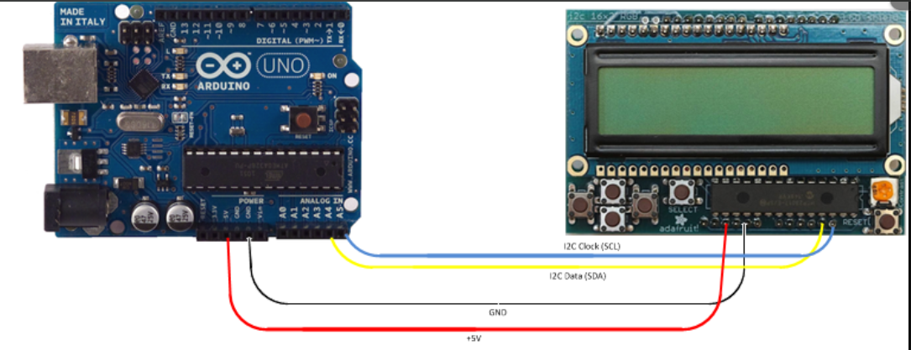
Figure 1: Adafruit RGB LCD shield wiring: 5V, GND, SDA → A4 and SCL → A5

1 Task 1: A traffic light on the LCD
Objective: run a three-state traffic light (RED → GREEN → YELLOW) and change the state machine.

Wiring
I2C LCD connections (used in every task)
From |  | To | Purpose
LCD GND | → | Nano GND | Ground
LCD VCC | → | Nano 5V | Power
LCD SDA | → | Nano A4 | I2C data
LCD SCL | → | Nano A5 | I2C clock

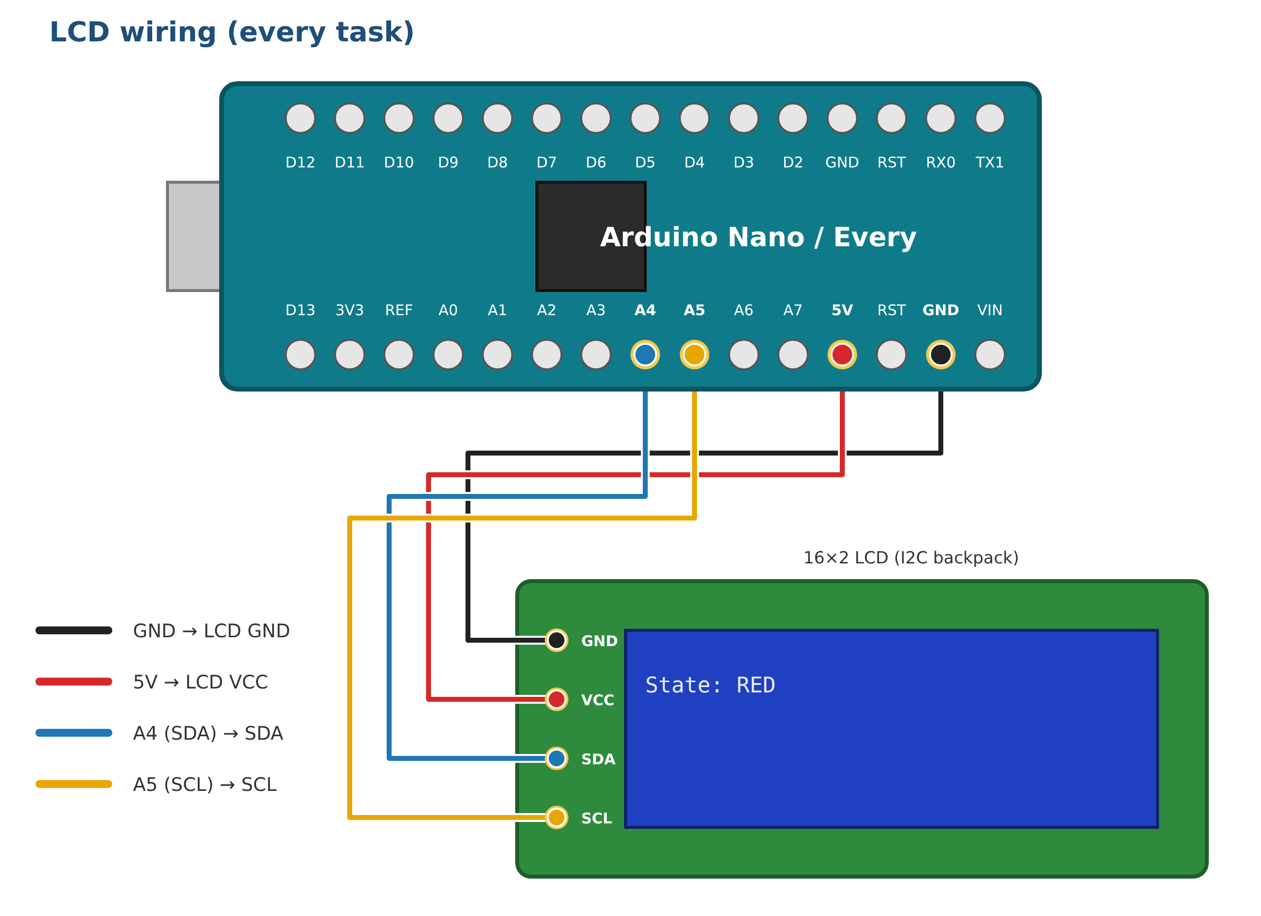
Figure 2: I2C backpack LCD wiring. For the RGB LCD shield, see Figure 1.

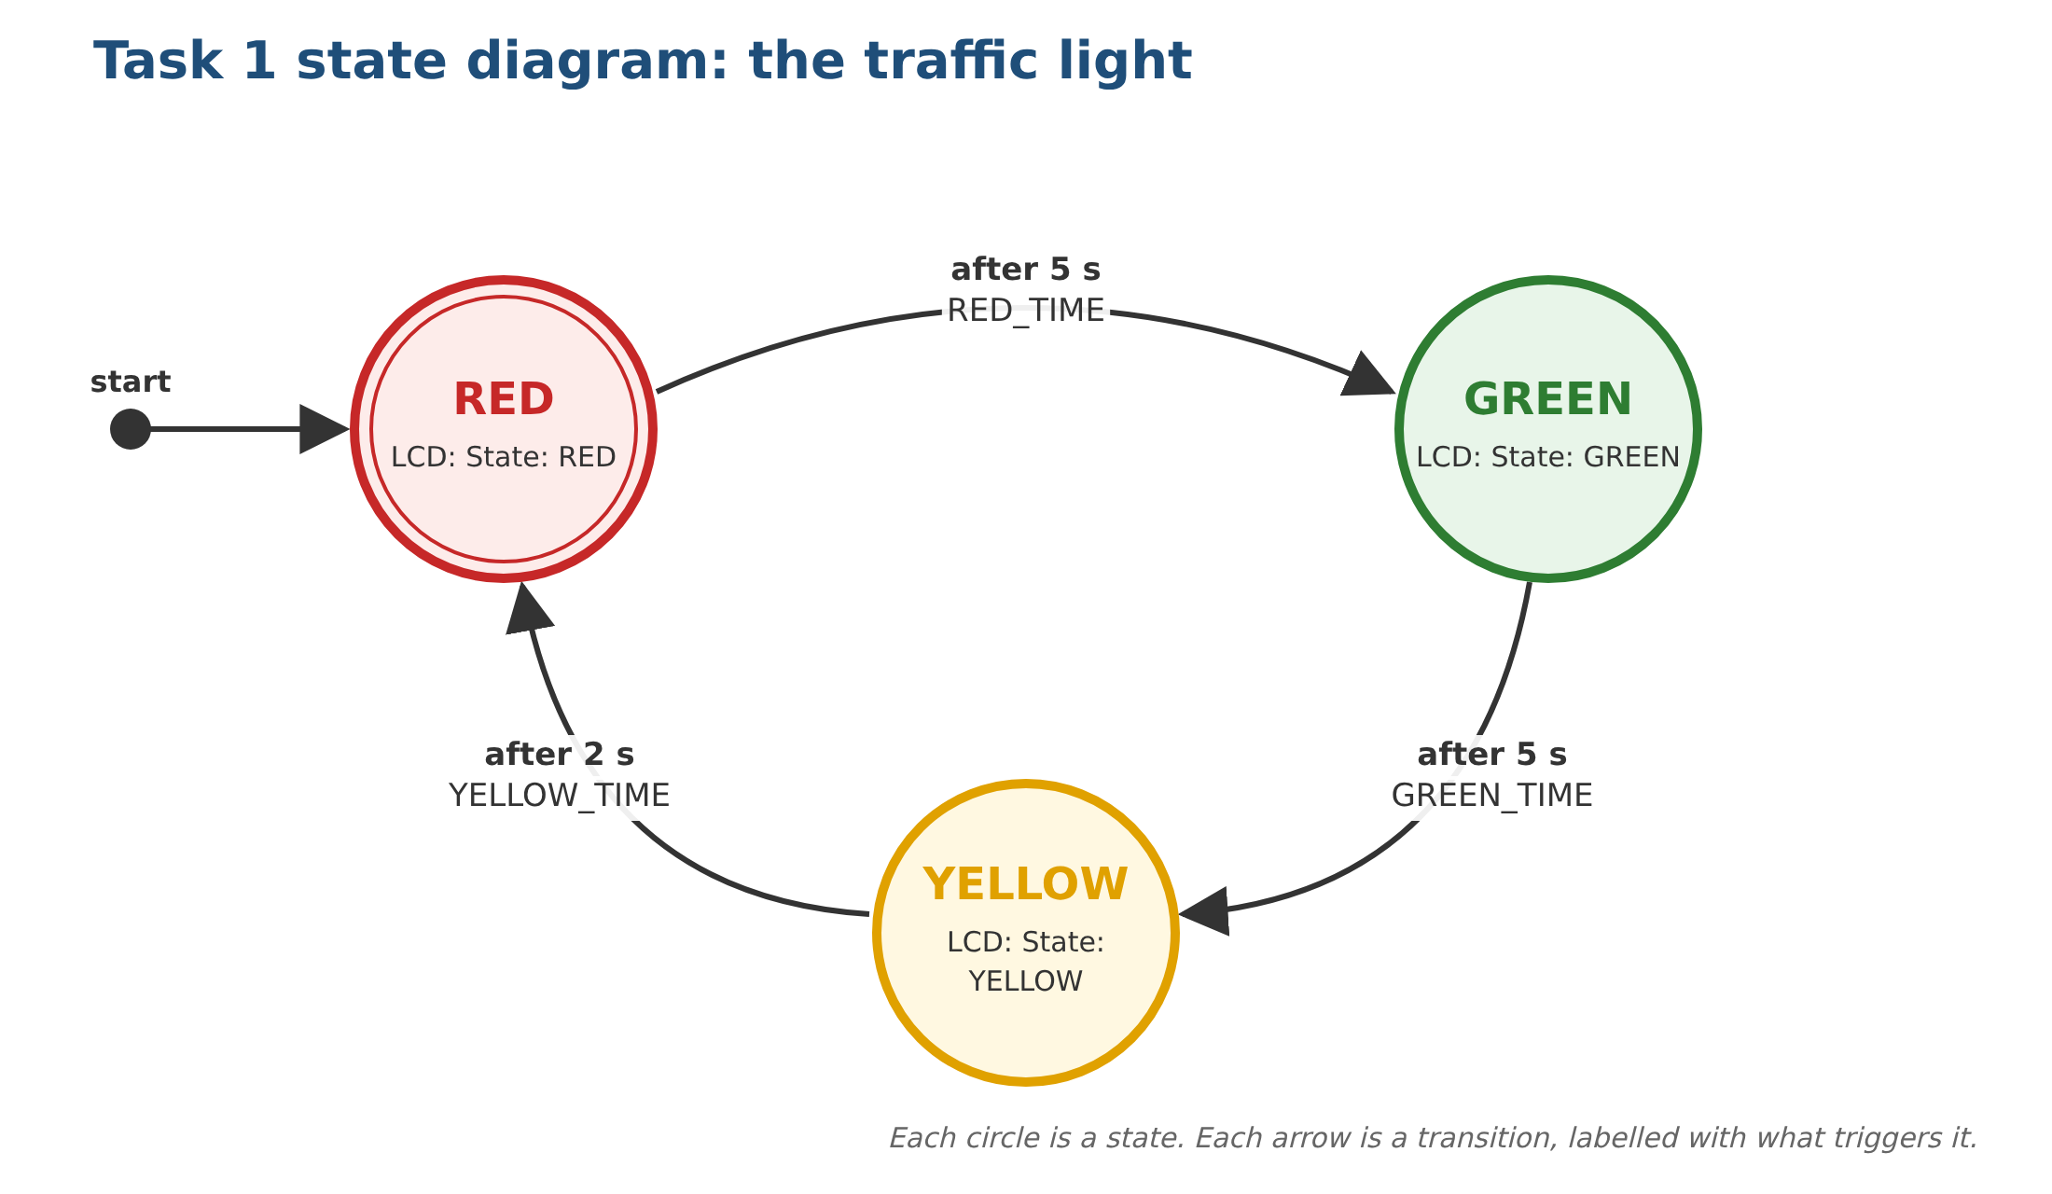
Figure 3: Task 1 state diagram

Code
Upload Task1_Traffic_Light. Use the folder for your display: I2C_Backpack_LCD (separate screen with four wires) or Adafruit_RGB_LCD_Shield (the shield with five buttons).

Expected result: the LCD shows State: RED for 5 s, State: GREEN for 5 s, State: YELLOW for 2 s, and repeats.

Task 1 questions

1a Run it
Upload the code and check the states change in the right order. (record) Take a photo of the LCD.

1b The transition table
Fill in the table from the code.
Current state | Time in state | Next state | LCD shows
RED
GREEN
YELLOW

How long does one full cycle take?
Your answer:

1c Change the timing
Make YELLOW last 3 seconds instead of 2. Which line did you change? Why is it better to keep the times in named constants such as YELLOW_TIME than to type delay(2000) inside the case?
Your answer:

1d Add a state
Add a fourth state, RED_AMBER, which shows State: RED+AMBER for 2 s, so the cycle becomes RED → RED_AMBER → GREEN → YELLOW → RED. Which three places in the code did you change? (record) Draw your new state diagram.
Your answer:

2 Task 2: Traffic light with real LEDs
Objective: drive a red, a yellow and a green LED from the state machine, with exactly one LED on at a time.

Wiring
LED connections (keep the LCD wiring from Task 1)
From |  | To | Purpose
Nano D5 | → | 220 Ω → red LED long leg | Red light
Nano D6 | → | 220 Ω → yellow LED long leg | Yellow light
Nano D7 | → | 220 Ω → green LED long leg | Green light
Each LED short leg | → | GND rail → Nano GND | Common ground

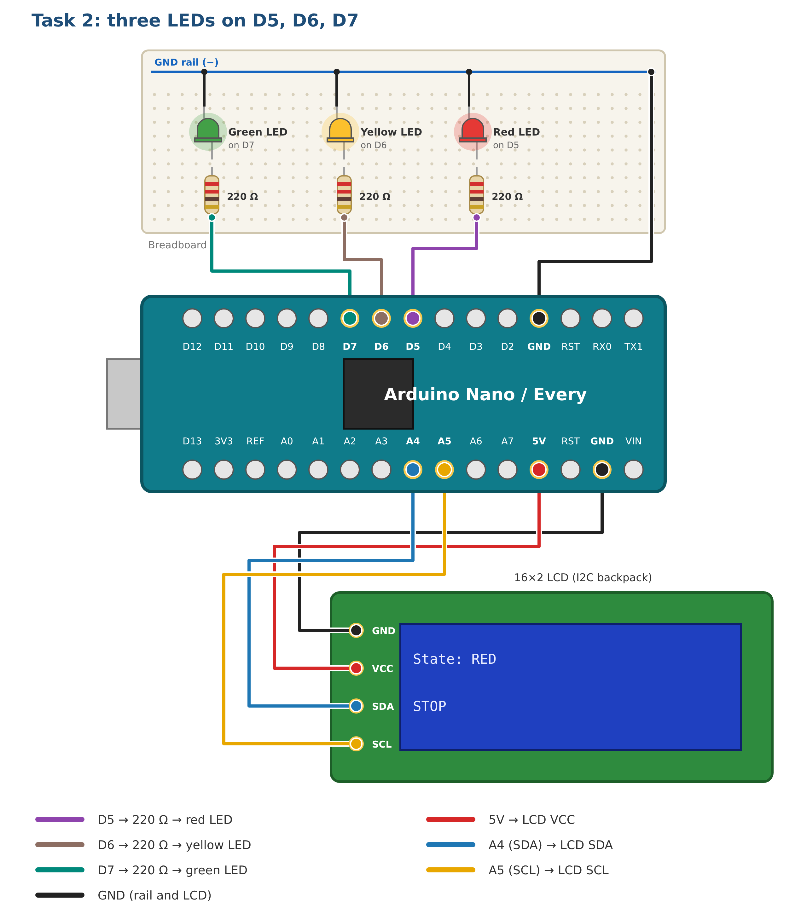
Figure 4: Task 2 wiring

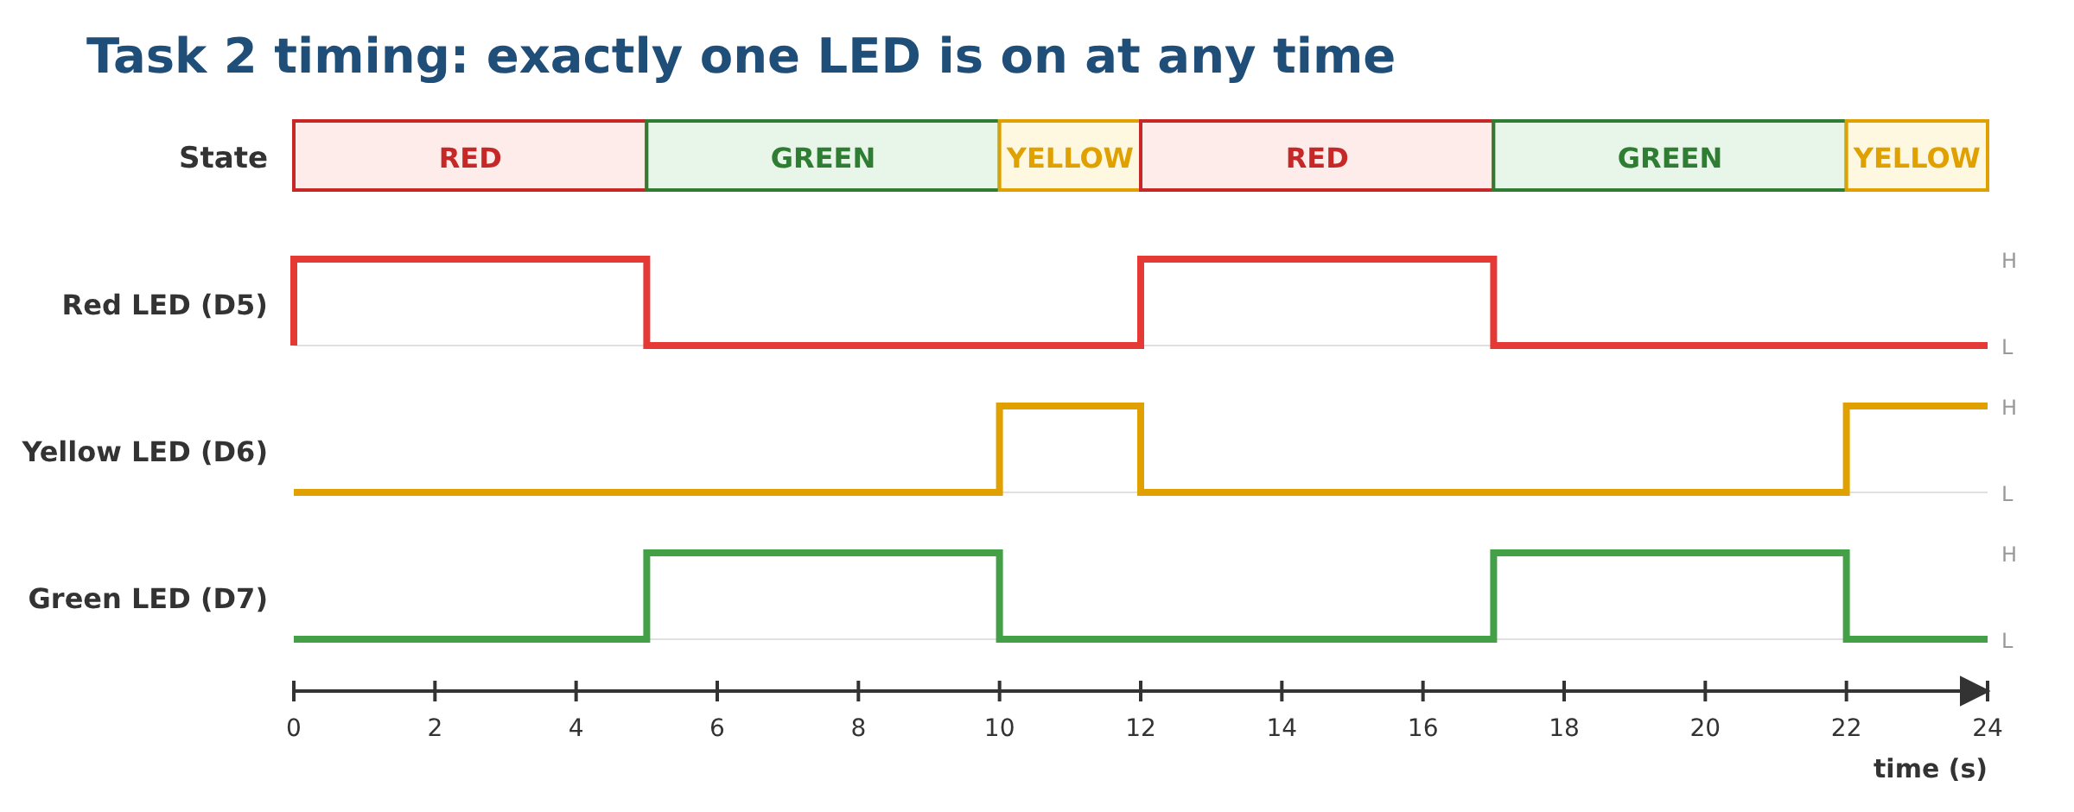
Figure 5: Task 2 LED outputs over two cycles

Code
Upload Task2_Traffic_Light_LEDs. Use the folder for your display: I2C_Backpack_LCD (separate screen with four wires) or Adafruit_RGB_LCD_Shield (the shield with five buttons).

Expected result: one LED at a time, in step with the LCD (State: RED / STOP, and so on).

Task 2 questions

2a Run it
(record) Paste a few lines from the Serial Monitor. They should look like this:
Serial Monitor
Traffic light ready
State 0: RED
State 1: GREEN
State 2: YELLOW

2b Forget to switch an LED off
In each case, replace the setLights(…) line with a single digitalWrite(…, HIGH) for that state’s LED. Run it for two cycles. What do the LEDs show, and why? Compare with Figure 5. Then put setLights() back.
Your answer:

2c The numbers behind the names
What would the LCD show if you changed the enum to { RED, YELLOW, GREEN } but left the two text arrays as they are? Why?
Your answer:

2d The resistor
A red LED drops about 2 V and the pin gives 5 V. Roughly how much current flows through the 220 Ω resistor?
Your answer:

3 Task 3: A pedestrian crossing
Objective: the cars’ light stays GREEN until the button is pressed and released, then goes YELLOW → WALK (countdown) → CLEAR → GREEN. The sketch uses millis() instead of delay(), and the button is debounced and reacts on the rising edge (when it is released).

Wiring
Add the button (keep the LEDs and LCD from Task 2)
From |  | To | Purpose
Nano D2 | → | Push button, one leg | Pedestrian button
Push button, other leg | → | GND rail | Pressing pulls D2 to 0 V

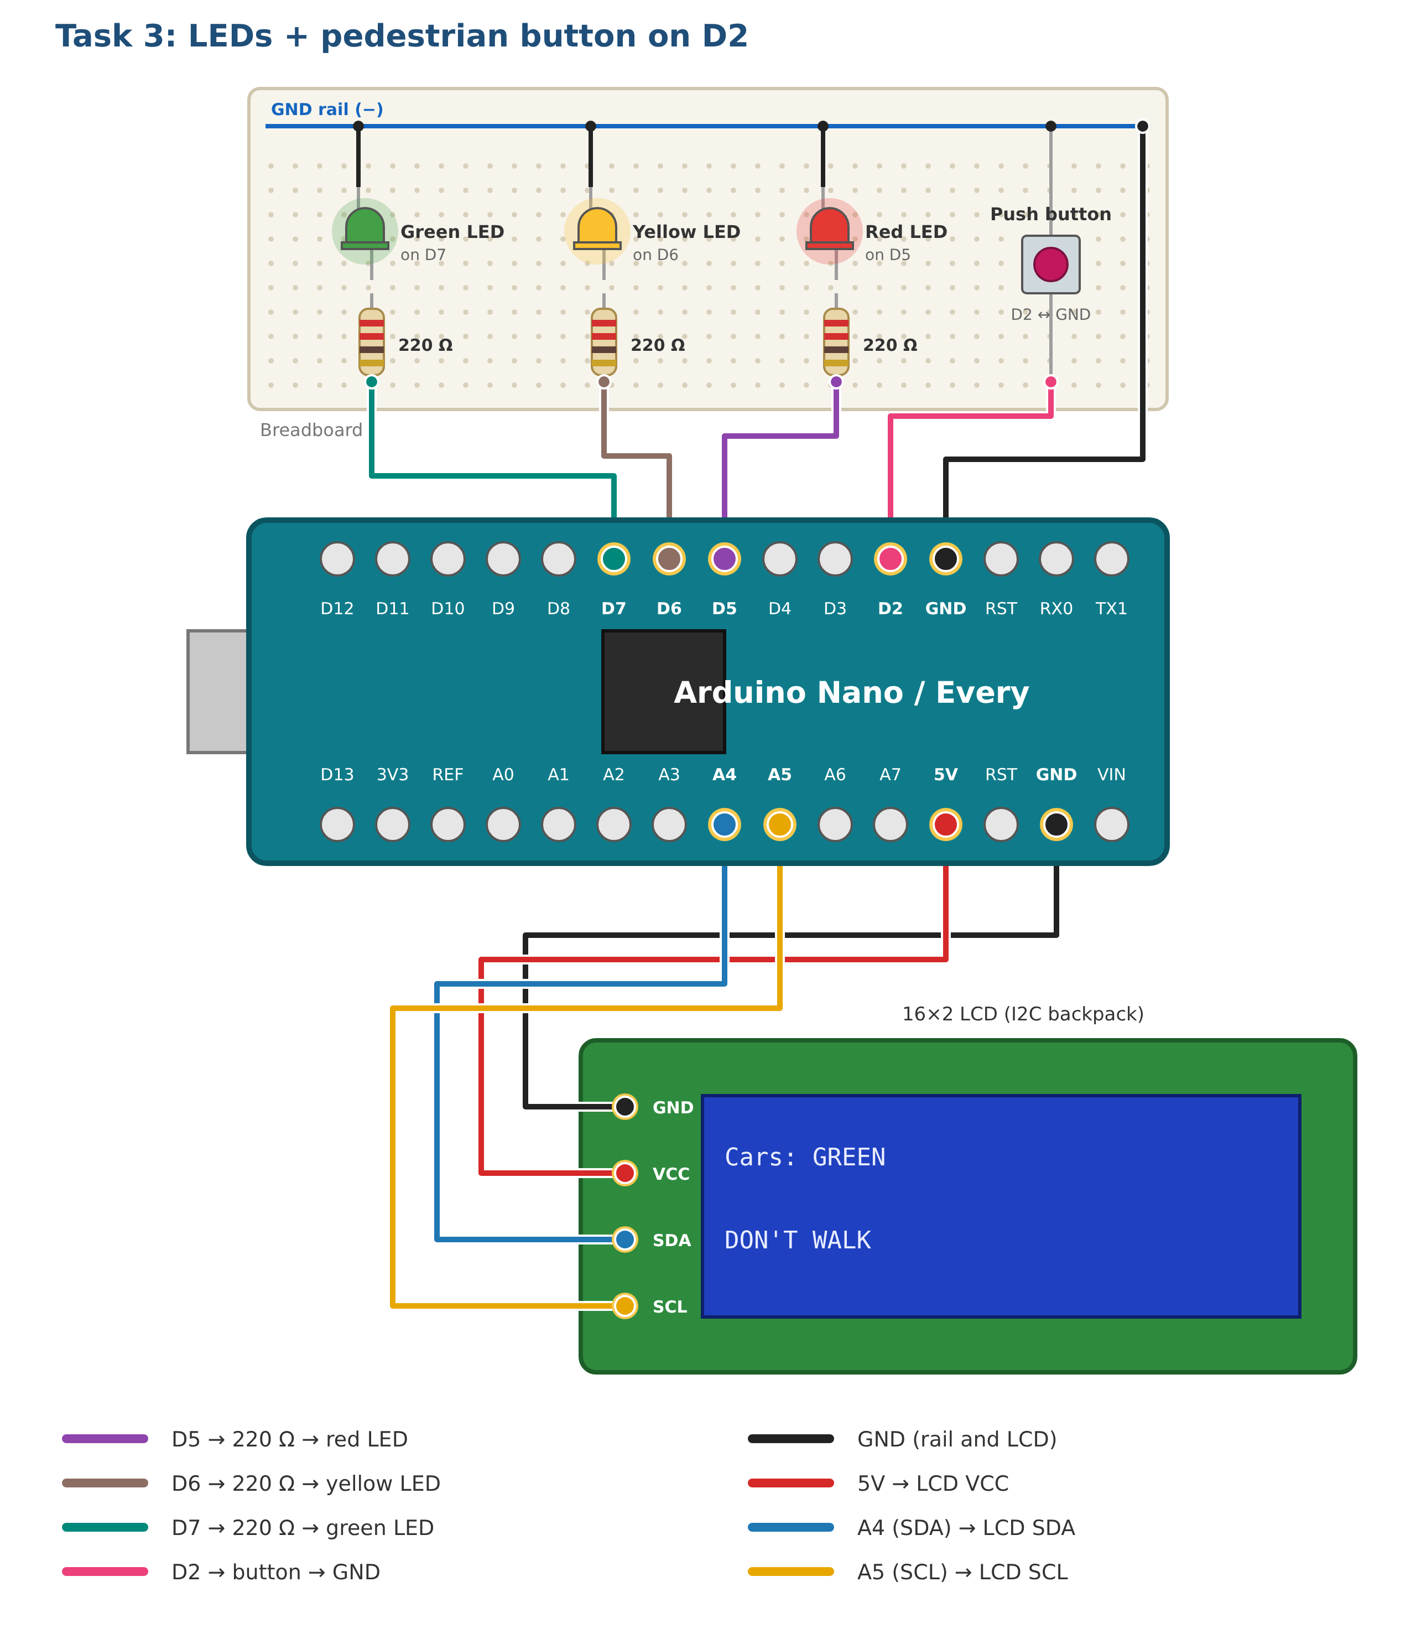
Figure 6: Task 3 wiring

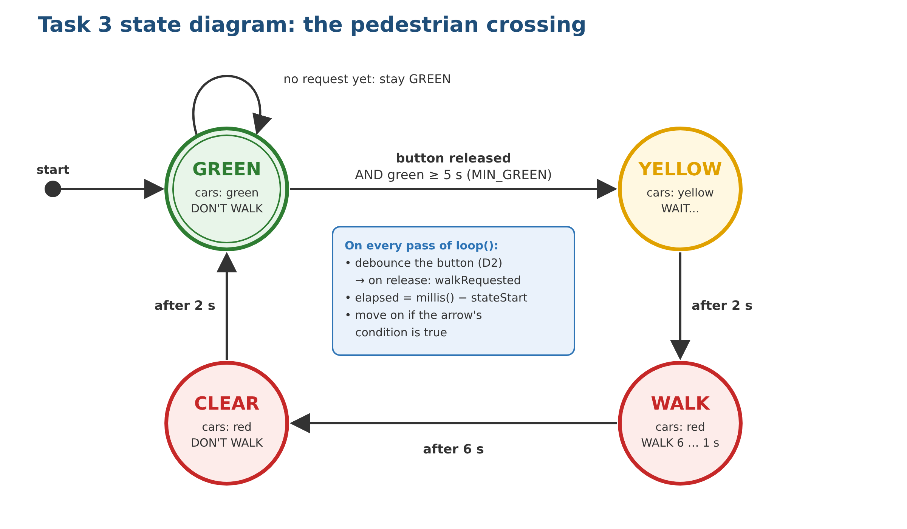
Figure 7: Task 3 state diagram

Code
Upload Task3_Pedestrian_Crossing. Use the folder for your display: I2C_Backpack_LCD (separate screen with four wires) or Adafruit_RGB_LCD_Shield (the shield with five buttons).

Expected result: the light stays GREEN until you press and release the button; the LCD shows WAIT..., then a WALK 6s … 1s countdown.

Task 3 questions

3a Run it
Press the button. (record) Paste the Serial Monitor output for one crossing. It should look like this:
Serial Monitor
Crossing ready
-> GREEN
Button released
-> YELLOW
-> WALK
-> CLEAR
-> GREEN

3b Press it at different times
Press and release the button at each of the times below. Use the state diagram to explain each result.
When you press and release | What happens | Why
Just after the light turns GREEN
When GREEN has been on for more than 5 s
During WALK
During CLEAR

3c delay() would miss it
If Task 2 checked the button at the top of loop(), what is the longest a pedestrian might have to hold it before the board noticed? Why does Task 3 notice a tap of a few milliseconds?
Your answer:

3d Rising edge and debouncing
1. Press the button and keep holding it. When does WAIT... appear: when you press, or when you let go? Which edge of the D2 signal (rising or falling) is the sketch reacting to?
2. In buttonReleased(), a new reading only counts once it has stayed the same for DEBOUNCE_TIME (50 ms). Why is this needed for a mechanical button?
3. Set DEBOUNCE_TIME to 0 and press the button several times. Does anything change? Would it matter if the button started a different action on every press, such as counting pedestrians?
Your answer:

